PROJECT NAME: SECURITY MONITORING WITH SPLUNK.

NAME: SAMUEL MERCY OLUWATOBI

EMAIL: smercyoluwatobi@gmail.com

STATUS: in progress-80% completed

EXPECTED COMPLETION: before the end of the month.

WHAT IS REMAINING: just to add images to the already answered question.

THE SOC PROJECT QUESTIONS IS BELOW

These questions focus on the core concepts of Splunk, including basic search, filtering, and understanding key fields. (TO BE SUBMITTED WITH SCREENSHOTS )
Scenario: Website Traffic Analysis 🌐
Your web server logs are indexed in Splunk. You want to see all traffic from a specific IP address 192.168.1.100.
Question: Write a search query to find all events with the clientip field equal to 192.168.1.100.
Scenario: Error Monitoring ⚠️
You're a system administrator and want to quickly find all critical errors in the last 24 hours. The logs use the terms "ERROR" and "FAILURE" to indicate critical issues.
Question: Construct an SPL query to search for events containing either "ERROR" or "FAILURE" within the _internal index.
Scenario: User Activity Tracking 👤
Your company's authentication logs are being monitored. You need to investigate a user named "jdoe" who may have attempted to log in multiple times unsuccessfully.
Question: Write a query that finds all events where the user field is "jdoe" and the status field is "failed".
Scenario: Identifying Top Spenders 💰
You have sales data for an e-commerce website. You want to identify the top 10 customers based on the total_revenue field.
Question: Use the top command to list the top 10 values for the customer_id field, sorted by the total_revenue.
Intermediate SPL Exercises
These questions require students to use transforming commands to manipulate and present data in meaningful ways.
Scenario: Calculating Daily Average Response Time ⏳
You're tasked with monitoring the performance of a web application. You have a web_traffic index with a field response_time_ms.
Question: Write an SPL query to calculate the average response_time_ms for each day over the past week and display it as a timechart.
Scenario: Counting Event Types by Host 📊
You need to create a summary of the different types of events (event_type) occurring on each host.
Question: Use the stats command to count the number of events for each event_type and group the results by host.
Bonus: How would you display this data in a table with a column for host and a column for the count of each event_type?
Scenario: Mapping IP Addresses to Geographic Locations 🗺️
You want to visualize the geographic origin of web attacks. Your logs have a src_ip field.
Question: Use the iplocation command to get the geographic information (city, country, etc.) for each src_ip in your events. Then, display the top 5 countries from which the attacks are originating.
Scenario: Finding Correlated Events 🔗
A user, "admin_user," is reporting a series of login failures followed by a successful login. You want to see the entire sequence of events for that user.
Question: Use the transaction command to group all login events for the user "admin_user" and display them as a single transaction.
Advanced SPL Exercises
These questions challenge students with more complex scenarios that combine multiple commands and advanced concepts.
Scenario: Detecting a Brute-Force Attack ⚔️
You suspect a brute-force attack is targeting your login page. You have a log of failed login attempts (action="login_failure"). A brute-force attack is defined as more than 10 failed login attempts from the same IP address (src_ip) within a 1-minute window.
Question: Write an SPL query that identifies all IP addresses that meet the brute-force criteria.
Scenario: Creating a Dashboard Panel 📈
Your manager needs a dashboard panel that shows the number of unique users (unique_users) who accessed a specific application (app="sales_portal") each day for the last 30 days.
Question: Create a search query that calculates the count of unique users per day and is suitable for a timechart visualization.
Scenario: Data Enrichment with a Lookup Table 🧠
You have a CSV file (threat_list.csv) with known malicious IP addresses. You want to use this list to identify any events in your web logs that originate from a malicious IP.
Question: Write a query that uses a lookup command to compare the src_ip field in your web logs against the threat_list.csv file and only returns events where a match is found.

IN THIS PROJECT I WILL BE MAKING USE OF THREE VMS

- UBUNTU-SERVER

REASONS: BEING THAT IT IS LIGHT WIGHT, STABLE, AND WIDELY SUPPORTED, making it perfect for running splunk without wasting resources. UBUNTU-SERVER(SPLUNK)

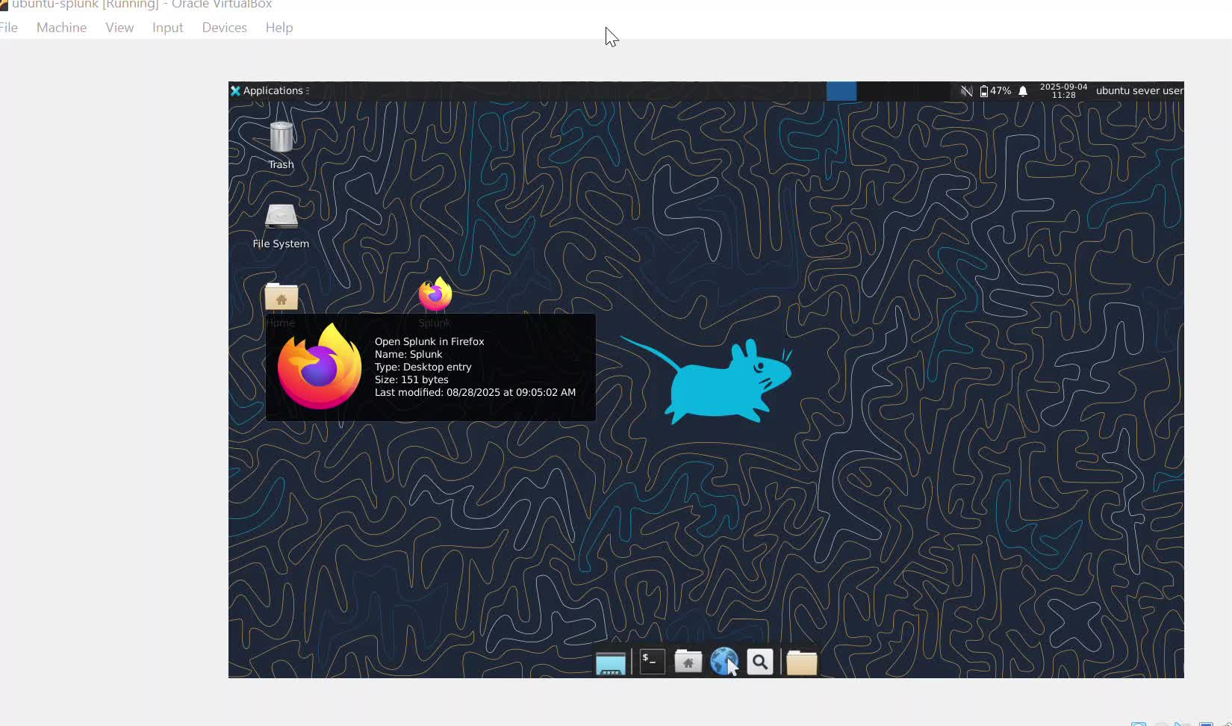

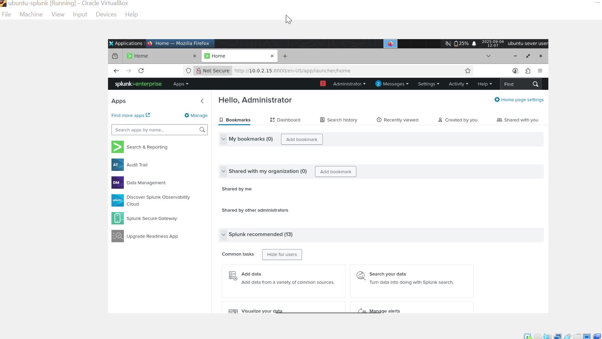

2. Win11-lab

REASONS: BEING THAT IT HOST MY SPLUNK FORWARDER, LETTING ME SAFELY COLLECT AND FORWARD LOGS FOR ANALYSIS TO MY SPLUNK


3. KALI LINUX

REASONS: BEING THAT I CAN BE ABLE TO CARRY OUT BRUTE FORCE ATTACK


CREATE INDEXES INSIDE SPLUNK.

GET READY WITH ME TO CREATE NEW INDEXES INSIDE MY SPLUNK : SUCH AS WEB (FOR WEB LOG), AUTH (FOR LINUX AUTH), WINEVENTLOG (FOR WIN EVENTS), SALES (FOR E-COMMERCE). WEB_TRAFFIC (FOR PERFORMANCE), ATTACKS (WHICH IS OPTIONAL).

- Web (for web log)
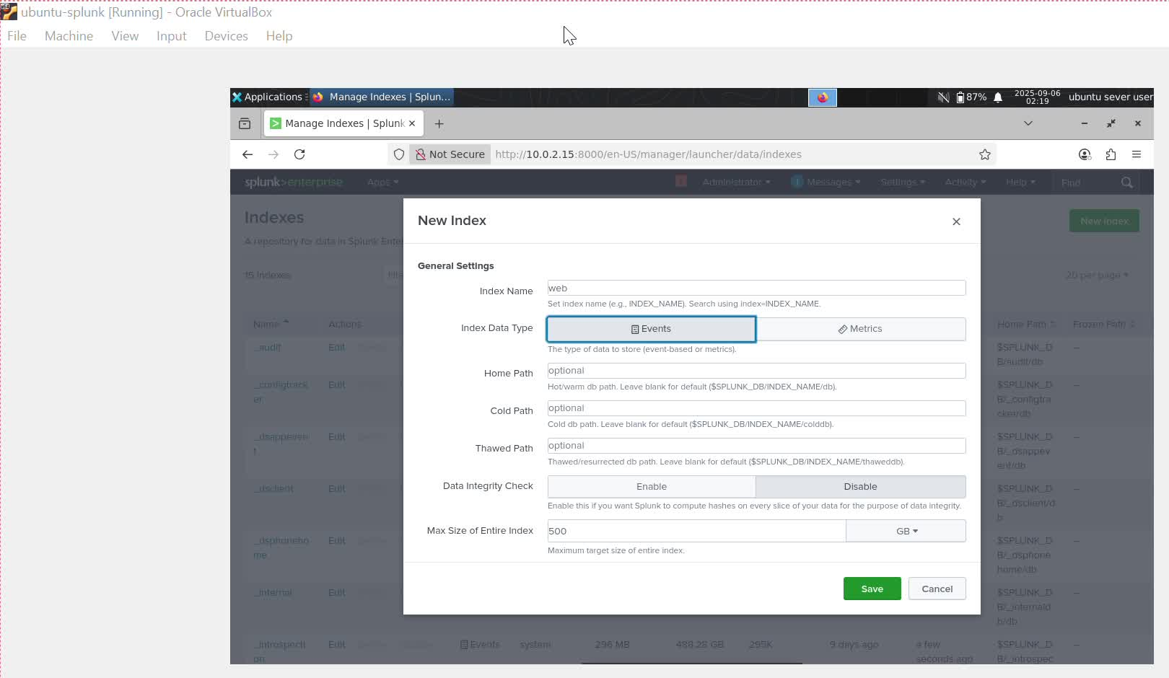

- Auth (for linux auth)
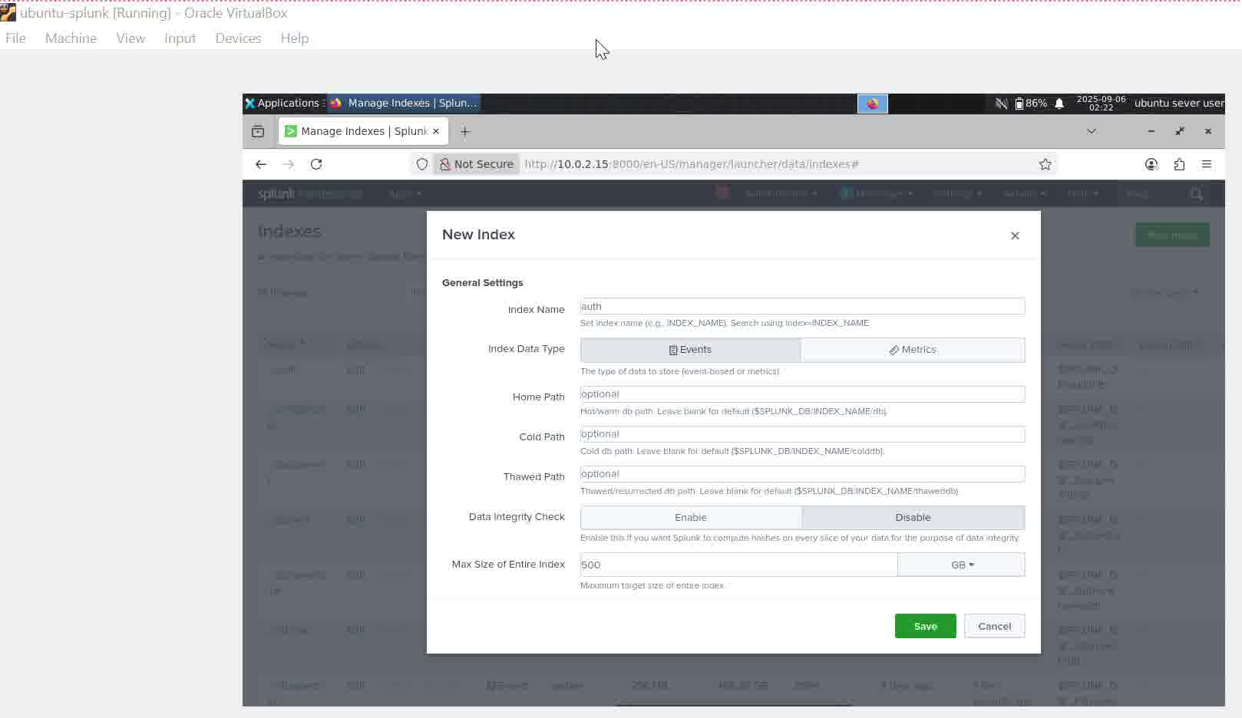

- Wineventlog (for win events)
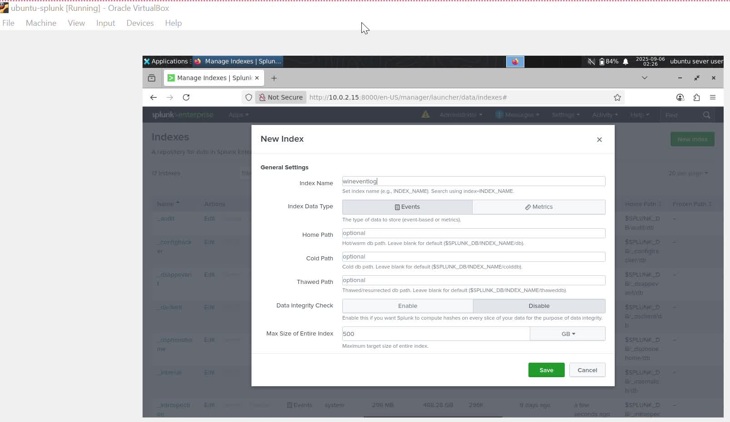

- Sales (for e-commerce)
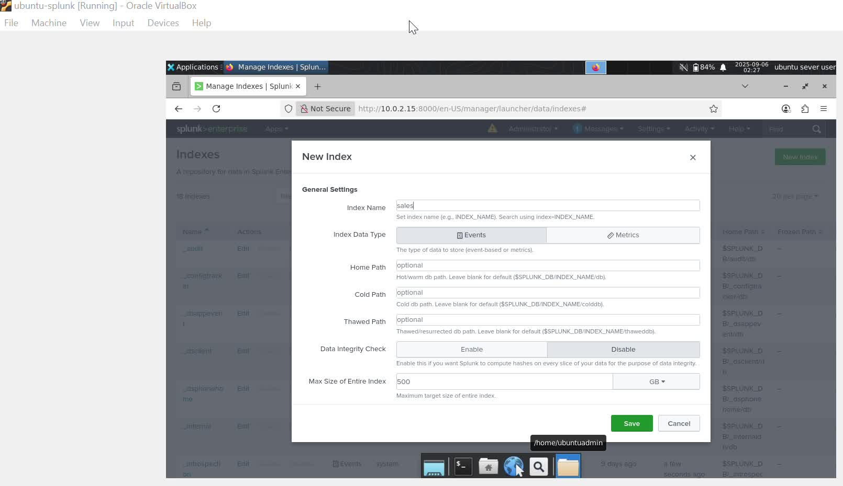

- Web_traffic (for performance)
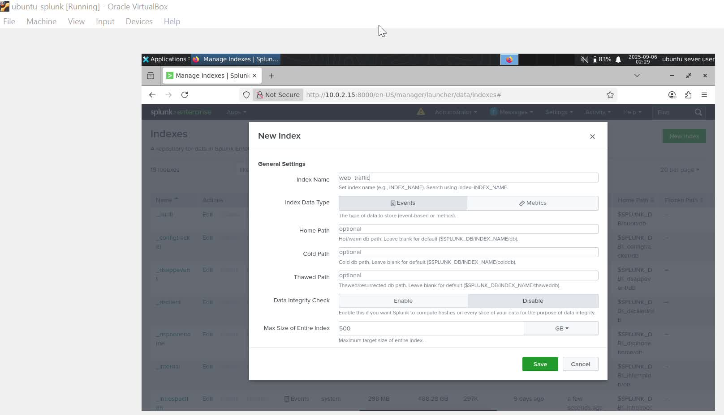

- Attacks
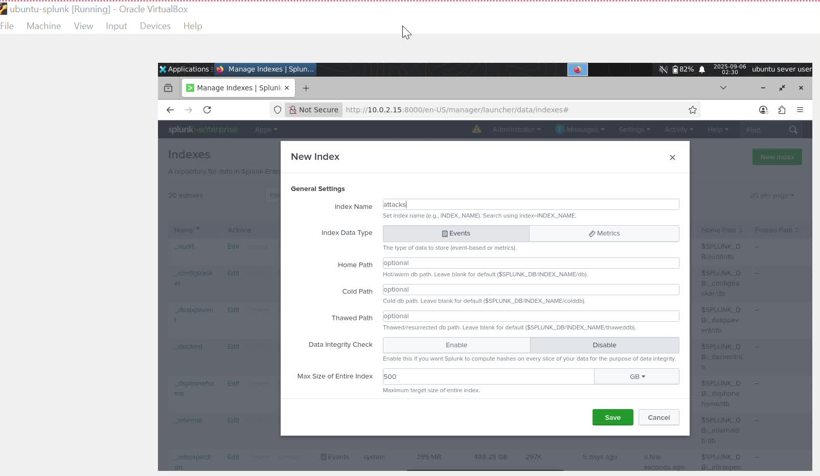

DATA ONBOARDING INTO SPLUNK.

- APACHE/NGINX access logs

First of all, i realised i d0 not have apache2. So have have to install it inside my ubuntu
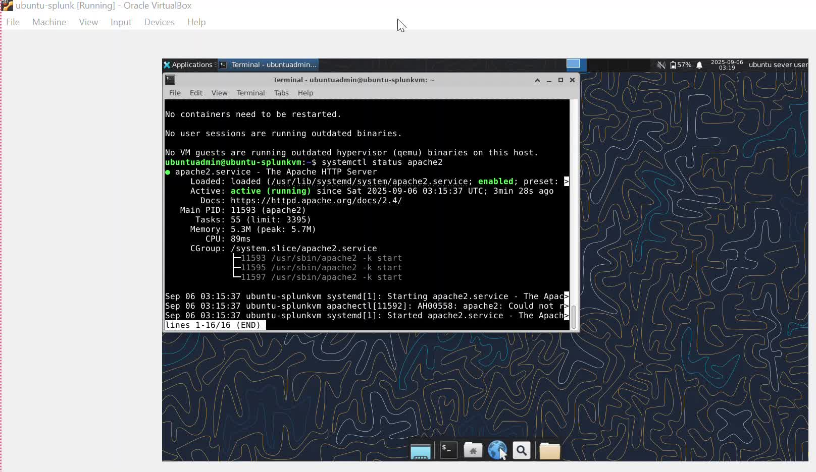

After that was created i went ahead to add data, monitor, files and directories to my /var/log/apache2/access.log

REVIEW
Input Type file monitor
Source Path /var/log/apache2/access.log
Continuously monitor yes
Source Type acces_combined
App Content search
Host ubuntu-splunkvm
Index web

- LINUX AUTH LOGS

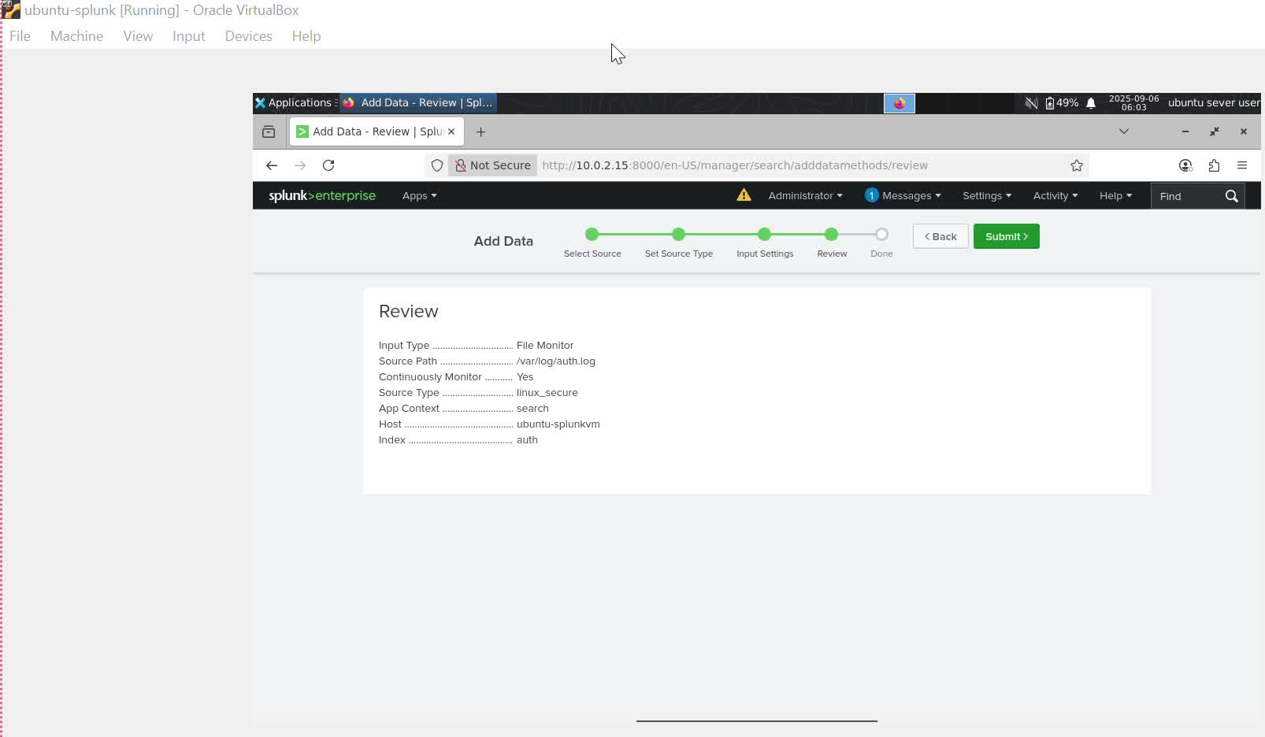

- WINDOW EVENT LOG

Making use of splunk universal forwarder, inside my win11-lab to send win-event-logs such as Security, Application, System to splunk.

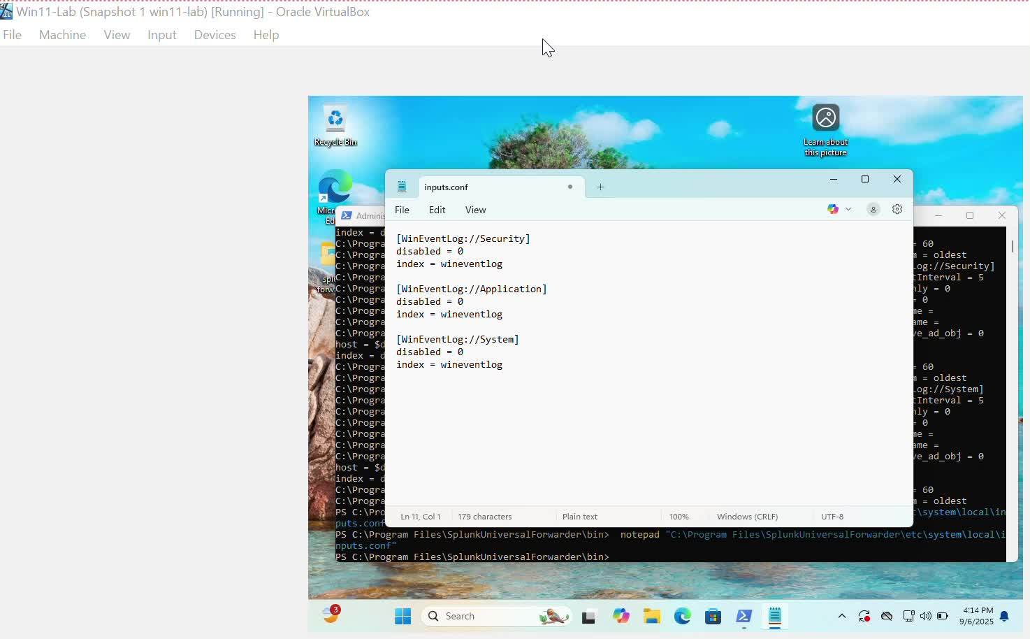

Now let me show you how my WinEventLog look like inside my splunk.
Mind you my win11-lab, hostname is DESKTOP-IH53T40 and my index is set to default or main
So Typing: index=* host=”DESKTOP-IH53T40” sourcetype=” WinEventLog:Applicaton” in the search and reporting will give you they pictures below
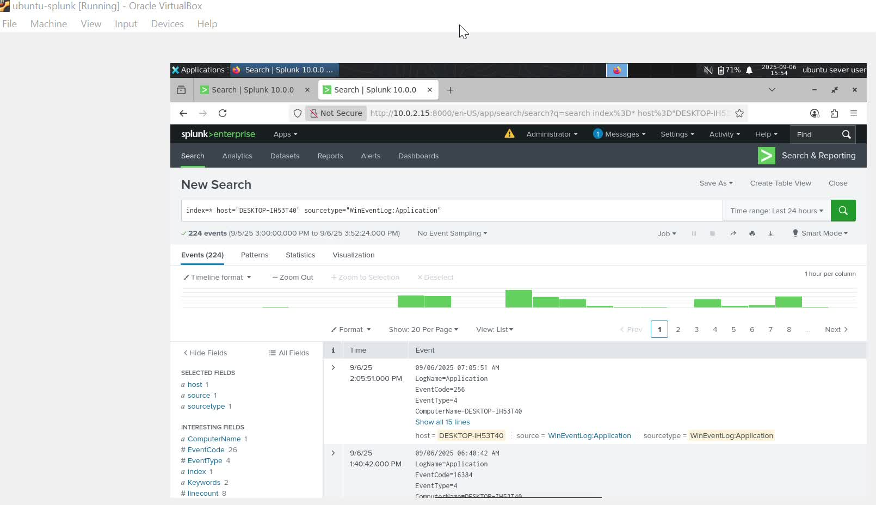

So Typing: index=* host=”DESKTOP-IH53T40” sourcetype=” WinEventLog:Security” in the search and reporting will give you they picture below
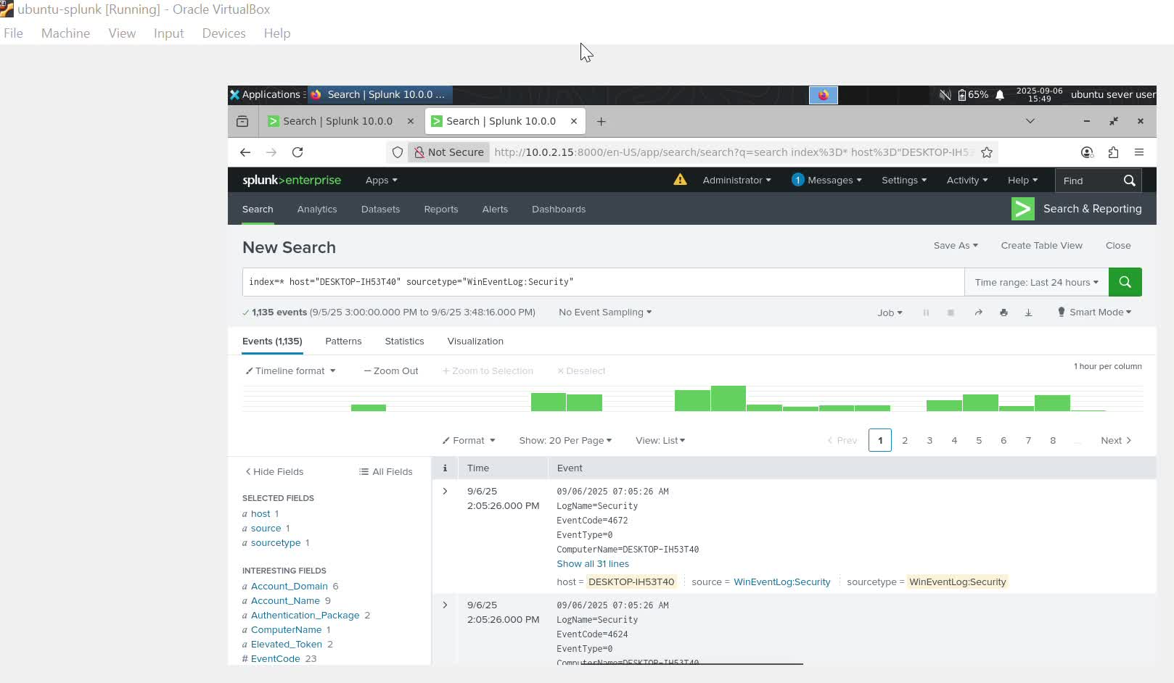

So Typing: index=* host=”DESKTOP-IH53T40” sourcetype=” WinEventLog:System” in the search and reporting will give you they picture below
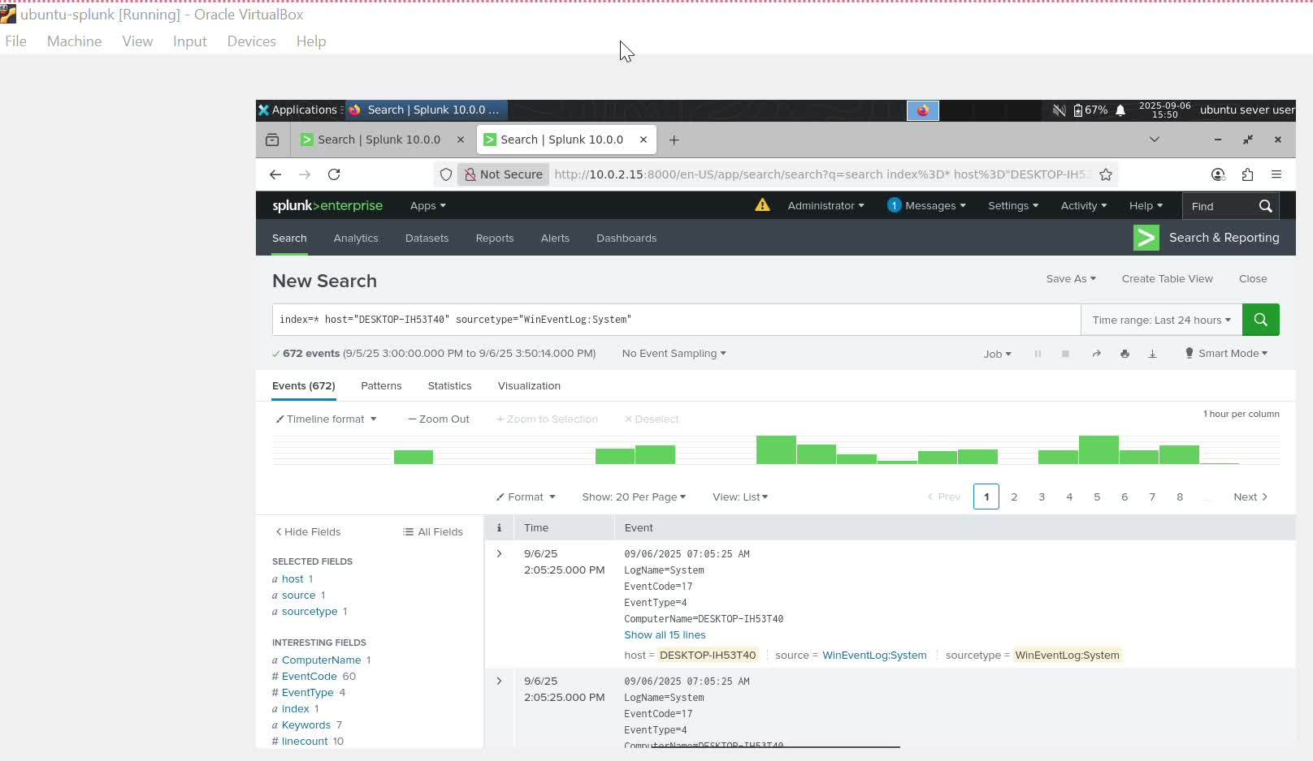

- LET GENERATE ATTACK/AUTH ACTIVITY FROM KALI

Using SSH brute attempts (reasons being that it is safe to use inside vms)
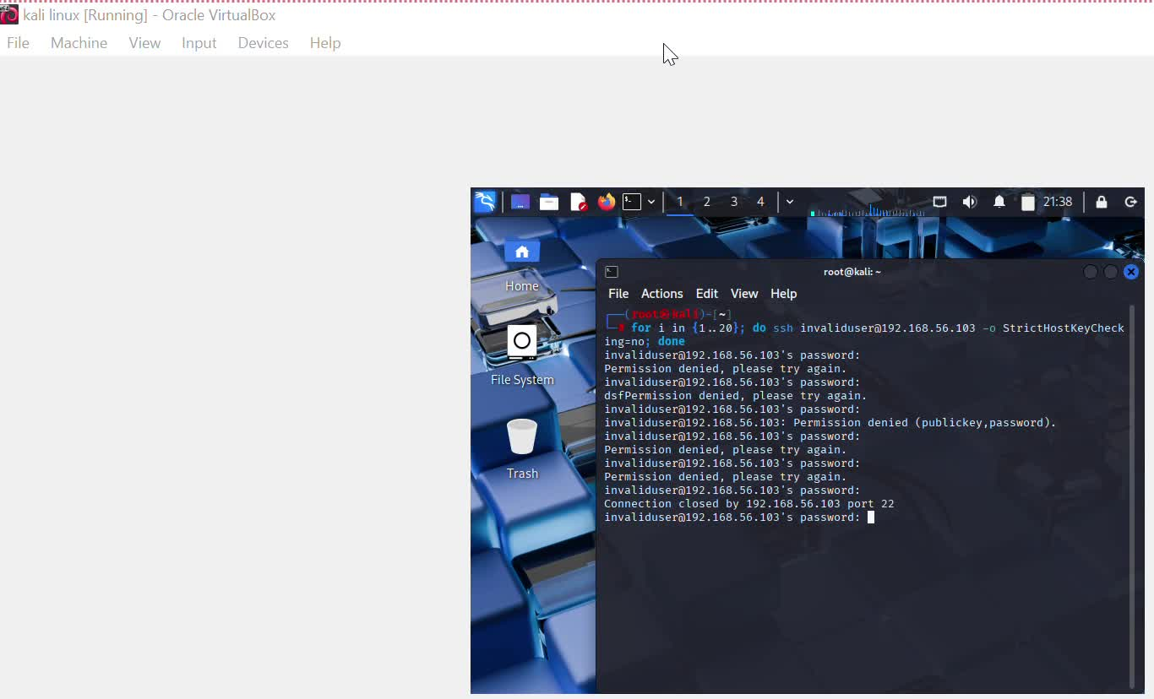
LET CHECK IN THE EVENT LOG IN SPLUNK

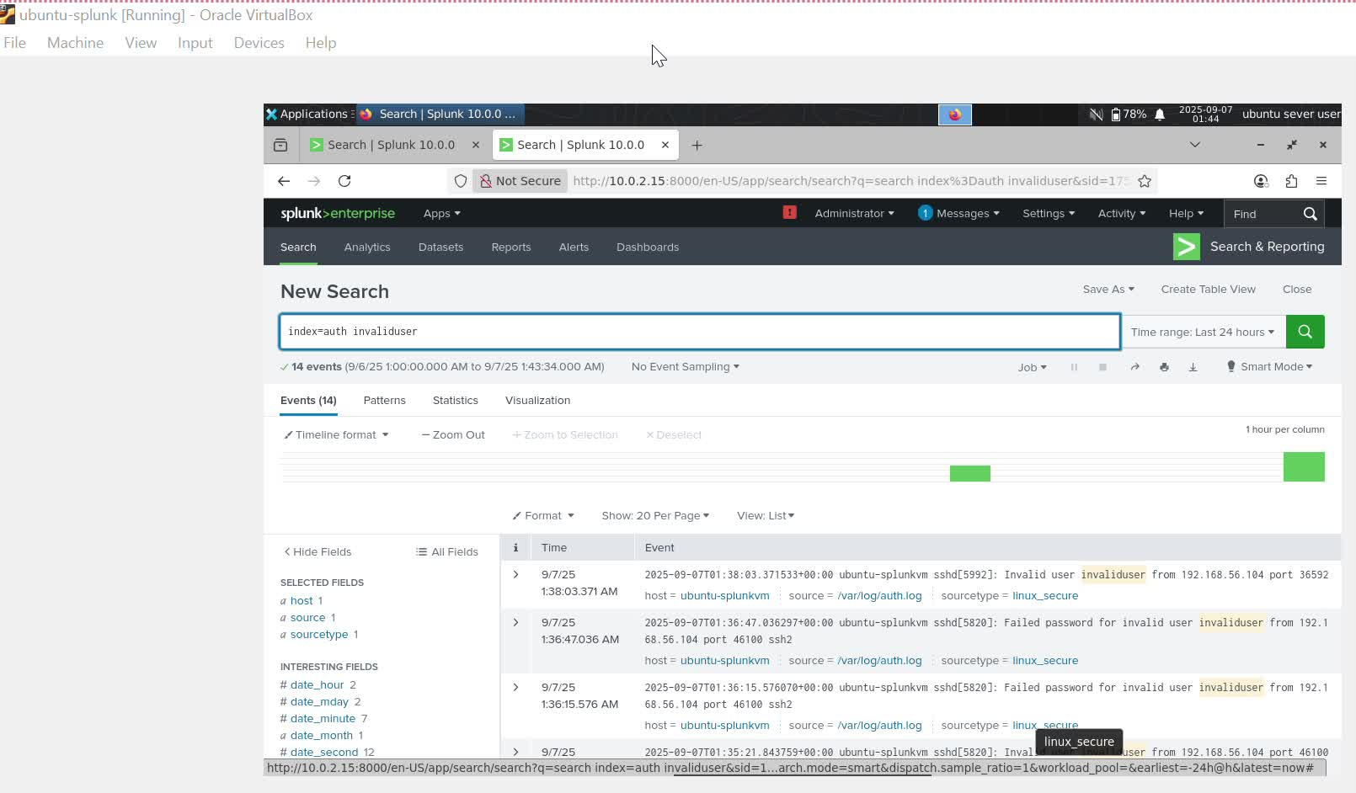

PROJECT QUESTIONS COMPLETED.
- Web traffic from a specific client ip 192.168.1.100. Due to the fact that i do not have any of my vms that use this specific ip or a data set, i could not generate a web traffic log for it.

Spl:
index=web clientip=”192.168.1.100” | table _time clientip method uri_path status
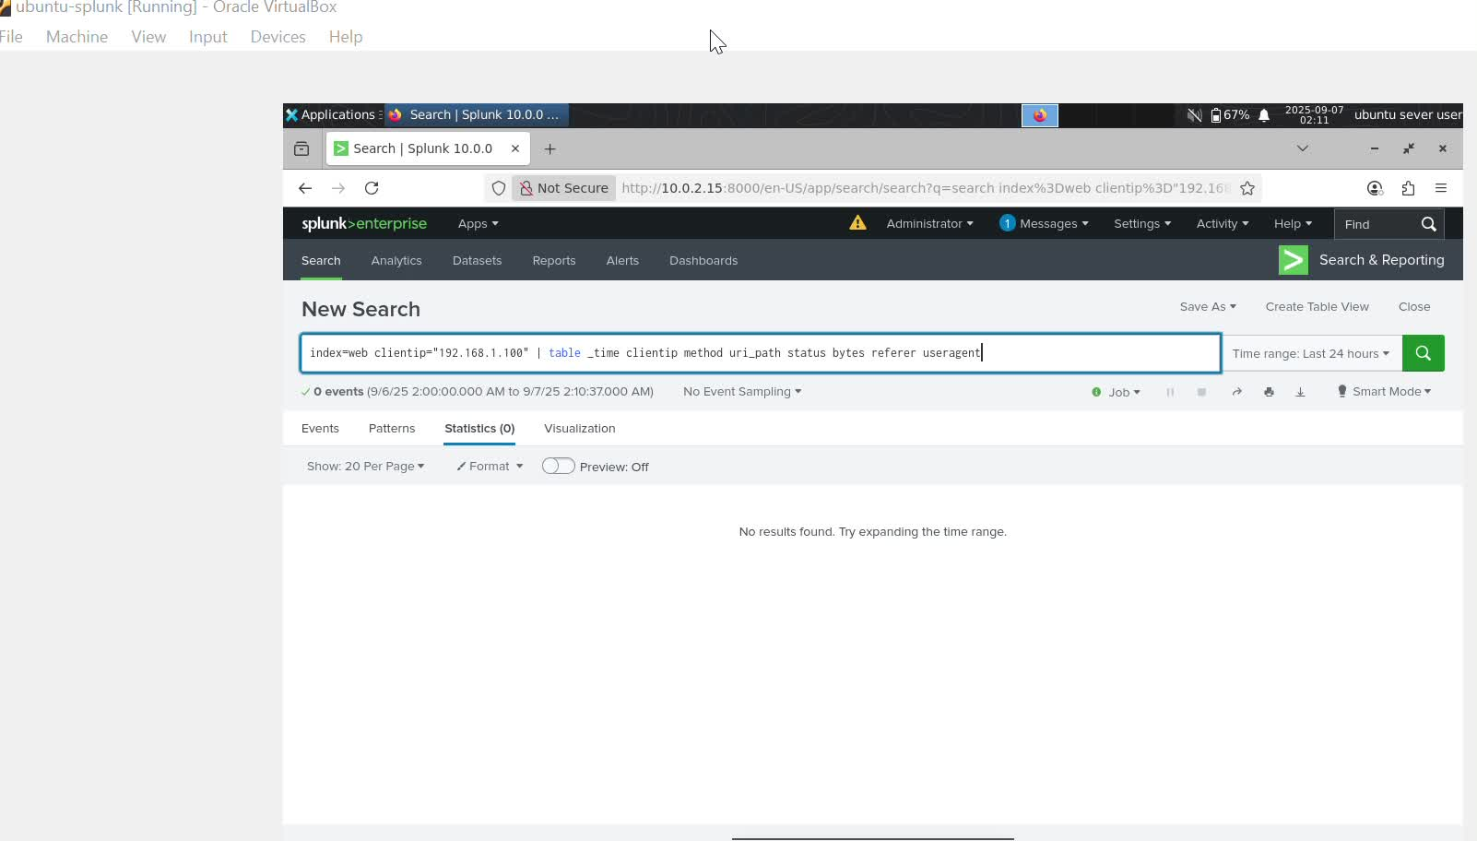

This is the web traffic from client ip 192.168.56.102. The ip belong to my win11-lab(vm). I was able to generate web traffic log for

- ERROR MONITORING- CRITICAL ERRORS LAST 24h in _internal

Spl
index=_internal earliest=-24h “ERROR” OR “FAILURE”

THE SPL is not for forwarded logs but for splunk's self-monitoring logs
Sources include: splunkd.log, metrics.log, scheduler.log

Mind you in this spl you can see user login failed.

- TO GENERATE THIS
PARTICULAR auth.log for user jdoe we can make use of kali

Inside The root terminal of kali, enter this command
Bash
For i in {1..20}; do ssh jdoe@<192.168.56.103> -o StrictHostKeyChecking=no done

Note: The ip you are seeing is for (ubuntu host only ip)

After inputting that command press enter
And kali will reply you with
Password for jdoe= you can put any keyword and it will generate failed password.
And each failed attempt is logged by ubuntu in /var/log/auth.log

THEN IN SPLUNK YOU MAKE USE OF SPL IN SEARCH AND REPORTING
SPL
index=auth user=jdoe status=failed | table _time host user status src_ip

- TO IDENTIFY TOP SPENDERS - TOP 10 BY TOTAL_REVENUE

To create a sales log we can use win11-lab to simulate sales events as text/csv logs then let uf forward them to my ubuntu (splunk)

In win11-lab open powershell as an administrator, run this script

Powershell

# Fake sales log generator
$logPath = "C:\logs\sales.log"
New-Item -ItemType Directory -Force -Path (Split-Path $logPath)

for ($i=0; $i -lt 20; $i++) {
$time = Get-Date -Format "yyyy-MM-dd HH:mm:ss"
$cust = "C" + (Get-Random -Minimum 100 -Maximum 110)
$item = Get-Random -InputObject "Laptop","Phone","Tablet","Headphones","Monitor"
$revenue = Get-Random -Minimum 50 -Maximum 1500
"$time customer_id=$cust item=$item total_revenue=$revenue" | Out-File -Append $logPath
}

This will create something like

2025-09-07 15:01:23 customer_id=C105 item=Phone total_revenue=350
2025-09-07 15:01:24 customer_id=C109 item=Laptop total_revenue=1200
2025-09-07 15:01:25 customer_id=C101 item=Tablet total_revenue=220

We have already configure splunk UF on Win11-lab before

So what next is to add an input in inputs.conf to monitor my sales log:

Inputs.conf

[monitor://C:\logs\sales.log]
index = sales
sourcetype = sales_log

Finally i will restart the UF service so it starts shipping to my ubuntu splunk.
Inside my splunk, i will click on search and reporting and i will type spl

Spl
index=sales | stats sum(total_revenue) as revenue by customer_id | sort - revenue | head 10

- Daily average response time over past week timechar

index=web_traffic would come from different web servers or load balancers (Apache, Nginx, IIS, F5, HAProxy, etc.).

Logs typically include:

Timestamp

Client IP

HTTP method + URL

Status code (200, 404, 500, etc.)

Response time in ms

Example (Nginx access log, custom format with response time):

192.168.1.55 - - [07/Sep/2025:15:02:01 +0000] "GET /api/login HTTP/1.1" 200 512 "-" "Mozilla/5.0" 35

The response time in ms. Should be the last number 35

Mind you Splunk UF on the web server forwards these logs into index=web_traffic.

So, typing this search quiery inside splunk
Spl
Index=web_traffic earliest= -7d@d | timechart span=1d avg(response_time_ms) as avg_ms

- Count event type by host (+ bonus pivot table)

host = automatically set by the UF (Win11, Ubuntu, maybe Kali).

event_type = either defined in your logs, created with Splunk’s field extractions, or faked with eval for practice.

Spl
index=* event_type=* | stats count by host event_type
Tabular matrix (host as rows, event_type as columns)
index=* event_type=* | chart count over host by event_type
I am suppose to Screenshot: Statistics (first SPL) and Visualization/Table (second SPL

- MAP IPS to geolocation and show top 10 countries
First of all in ubuntu let simulate logs that contain src_ip based on the fact that their is no external traffic.
Let Make a log file with random IPs: in my ubuntu vm

cat <<EOF > /var/log/attack.log
2025-09-07 15:01:23 src_ip=185.60.216.35 action=login_failed
2025-09-07 15:01:24 src_ip=203.0.113.42 action=scan
2025-09-07 15:01:25 src_ip=8.8.8.8 action=login_success
2025-09-07 15:01:26 src_ip=91.198.174.192 action=exploit_attempt
2025-09-07 15:01:27 src_ip=202.54.1.5 action=ddos
EOF

My Universal Forwarder is already configured to monitor /var/log/attack.log into index=attacks
Spl
index=web OR index=attacks src_ip=*
| iplocation src_ip
| top limit=5 Country

- Correlated sequence with transaction for admin_user
Use real SSH on Ubuntu
The reasons why we are able to use ssh is becaues the two vms that kali and ubuntu are set to host only adapter
Where they can speak to each other
On your Kali root terminal, try this against Ubuntu:
Bash
for i in {1..5}; do ssh admin_user@<192.168.56.103> -o StrictHostKeyChecking=no; done
Note: ip 192.168.56.103 belongs to my ubuntu host only ip
Then one successful login:
ssh admin_user@<192.168.56.103>
If admin_user exists on Ubuntu, the. failed ones will show as:
Failed password for admin_user from <KALI_IP>
The success will show as:
Accepted password for admin_user from <KALI_IP>
My UF on Ubuntu is monitoring /var/log/auth.log into index=auth.
SPL
index=auth user="admin_user" (status=failed OR status=success) | transaction user startswith=(status=failed) endswith=(status=success) maxspan=1h | table _time duration eventcount values(status) values(src_ip) host

- Detect brute‑force (>10 failures from same IP within 1 minute)
We can use kali to carry out this brute-force attack by using ubuntu host ip
ubuntu serve as the victim why splunk serve as the siem tools to monitor the activities.
SPL
index=auth action="login_failure" | bin _time span=1m | stats count as failures by src_ip _time | where failures > 10 | sort - failures Add host if present: by src_ip host _time.

- Dashboard panel — daily unique users for app="sales_portal" (last 30 days)
SPL (panel search)index=app_logs app="sales_portal" earliest=-30d@d | timechart span=1d dc(user) as unique_users Create panel: Save As → Dashboard Panel → New/Existing Dashboard → Visualization: timechart.

- Data enrichment with CSV lookup (threat_list.csv)

Upload the CSV Settings → Lookups → Lookup table files → Add new → Upload threat_list.csv (must include a header like src_ip). Create a Lookup definition named threat_list mapped to that file.
SPL
(return only matches) index=web src_ip=* | lookup threat_list src_ip OUTPUT src_ip as matched_ip | where isnotnull(matched_ip) | table _time src_ip uri_path status host

